PROJECT 1 :

TYPING SPEED CALCULATOR

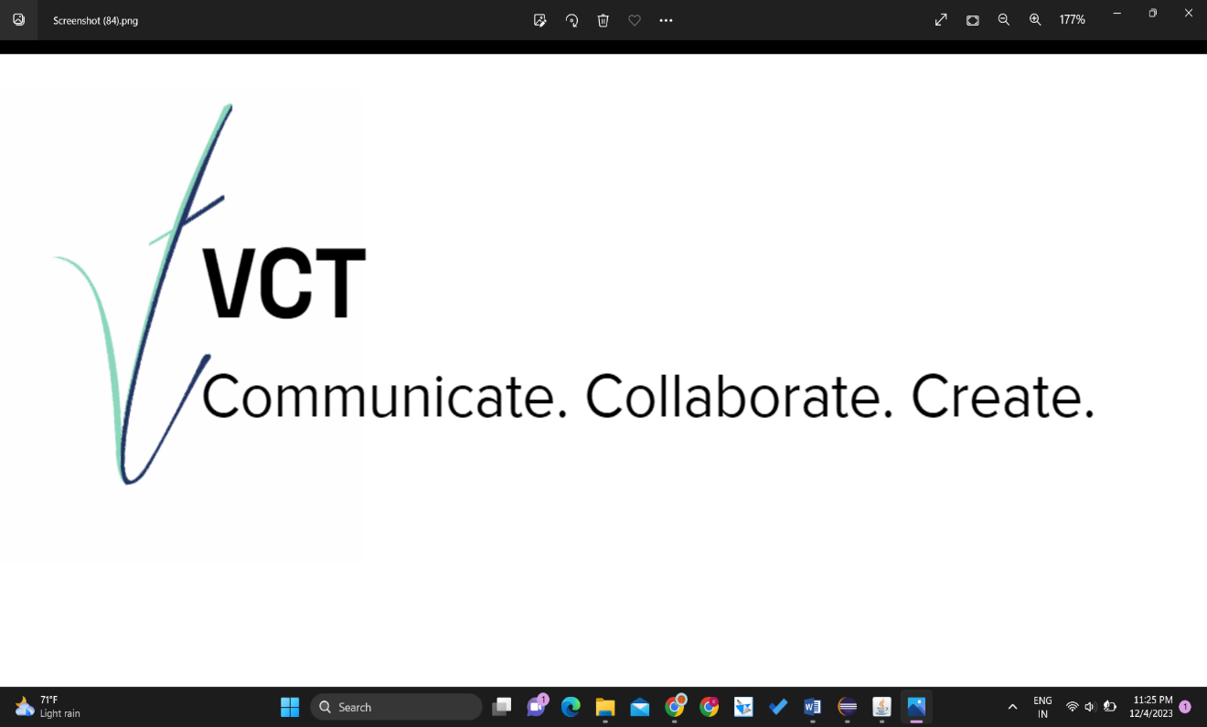

NAME :ABHISHEK

USN :1RR22CS002

E-MAIL : abhishektarnalli@gmail.com

# ACKNOWLEDGEMENT

While I was making this project, a lot of information that I found helped me in chapter and I am glad that I was able to complete this project and was able to understand many things.

It gave me an immense pleasure while doing this project because it was not just a project but, a source to learn not just about chapter but also I inculcated many qualities like responsibility , punctuality , confidence and whatnot.

The journey of making this project was so nice and in all this my teachers who supported me all the time, cleared my doubts and the parents support also played a big role and my friends too helped me. I thank to all of them and wish that they keep supporting me like this.

Doing work on time is something everyone needs to learn and through this project I have improved my timing and also it made my thinking skills better.

A project is a bridge between theoretical and practical learning and with this thinking I worked on the project and made it successful due to timely support and efforts of all who helped me.

Once again thank you Sir/Ma'am to give me this project and to make me learn so many things .I have no more valuable words to express my thanks, but my heart is still full of favor received from every person.

ABOUT THE C0MPANY:

Varcons Technologies Pvt Ltd is a digital service provider that aims to provide software, designing and marketing solutions to individuals and businesses. At VCT, we believe that service and quality is the key to success.

We provide all kinds of technological and designing solutions from Billing Software to Web Designs or any custom demand that you may have. Experience the service like none other!

Some of our services include:

Development - We develop responsive, functional and super-fast websites. We keep User Experience in mind while creating websites. A website should load quickly and should be accessible even on a small view-port and slow internet connection, we develop sophisticated customizable ssoftware’s using Java and other programming Languages as per the clients needs’

Mobile Application - We offer a wide range of professional android, iOS & Hybrid app development services for our global clients, from a start up to a large enterprise.

Design - We offer professional Graphic design, Brochure design & Logo design. We are experts in crafting visual content to convey the right message to the customers.

Consultancy - We are here to provide you with expert advice on your design and development requirement.

Videos - We create a polished professional video that impresses your audience

# INDEX

|  |  |  |
| --- | --- | --- |
| NO.S | TITLE | PAGE NO. |
| 1 | Brief overview on project | 05 |
| 2 | Advantages and challenges while completing project | 05 |
| 3 | Software and hardware requirement for project | 06 |
| 4 | Implementation of project | 06-08 |
| 5 | Conclusion | 08 |
| 6 | Bibliography | 08-10 |

**A BRIEF OVERVIEW ON THE PROJECT**:

The Typing Speed Calculator Java project is a console-based application developed to evaluate the typing speed and accuracy of users. The program prompts users to input a predefined passage or allows them to type a custom text. Once the user completes the typing task, the application calculates the typing speed in words per minute (WPM) and accuracy based on the number of correctly typed words.

The project is implemented in Java, focusing on core functionality such as tracking user input, calculating the time taken to complete the typing task, and determining accuracy by comparing the input with the correct passage. The logic ensures precise measurement of typing speed and accuracy, providing users with valuable feedback on their typing proficiency.

This Typing Speed Calculator project can be utilized in various scenarios, including educational environments, typing training programs, or as a simple self-assessment tool for individuals looking to enhance their typing skills without the need for a graphical user interface.

# 2.ADVANTAGES AND CHALLENGES WHILE COMPLETING THE PROJECT.

*1. Skill Development*: Enhances Java programming skills.

*2. Educational Value*: Practical tool for typing skill assessment.

*3. Real-world Applicability*: Useful in education and job assessments.

*4. Algorithmic Thinking*: Fosters efficient algorithm design.

5. Customization: Allows for creative features like customizable passages.

Challenges:

*1. Accuracy Calculation:* Handling typos and punctuation for precise accuracy.

*2. User Input*: Efficiently managing typing input and detecting completion.

*3. Timer Accuracy*: Implementing a precise timer without disrupting user experience.

*4. Error Handling*: Gracefully managing unexpected scenarios.

*5. Platform Compatibility*: Ensuring functionality across diverse environments.

*6. User Experience*: Enhancing without a graphical interface poses challenges.

**SOFTWARE AND HARDWAREREQUIRMENTS FOR JAVA PROJECT :**

# Hardware Requirement for Java:

Minimum hardware requirement to download Java on your Windows operating system as follows:

* Minimum Windows 95software
* IBM-compatible 486system
* Hard Drive and Minimum of 8 MBmemory
* A CD-ROMdrive
* Mouse, keyboard and soundcard

# Software requirement for Java:

Nowadays, Java is supported by almost every operating systems. Whether it is a Windows, Macintosh and UNIX all supports the Java application development. So you can download any of the operating system on your personal computer. Here are the minimum requirement.

The software require for project includes package necessary to successfully compile and build the program.

* Operating System
* Java SDK or JRE 1.6 orhigher
* Java Servlet Container (Free Servlet Containeravailable)
* Supported Database and library that supports the database connection withJava.

IMPLEMENTATION OF THE PROJECT with Screenshots:

CODE:

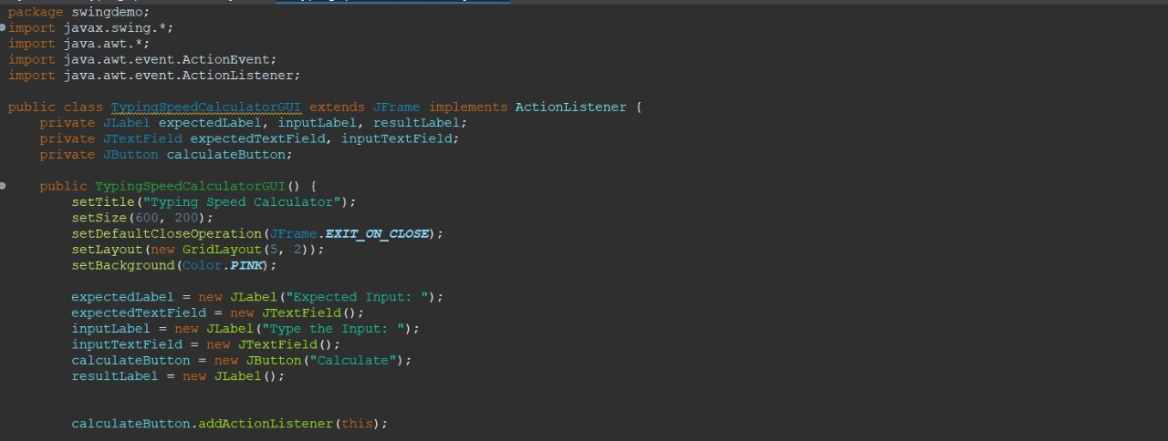

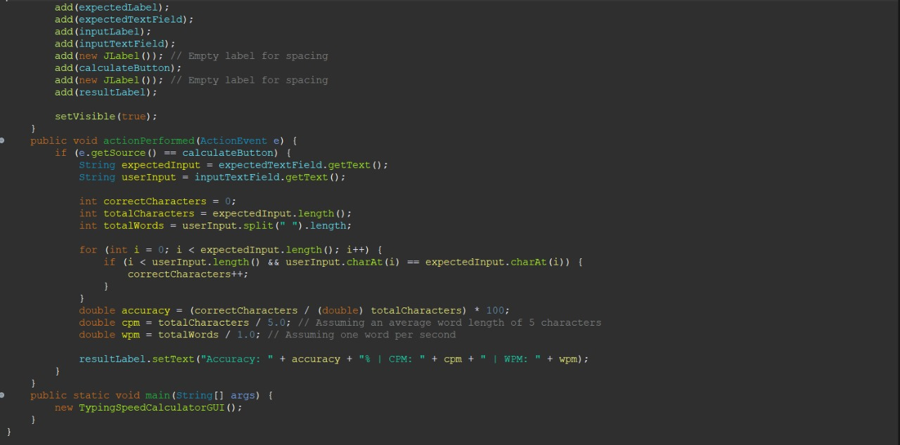

***SCREENSHOT OF OUTPUT:-***

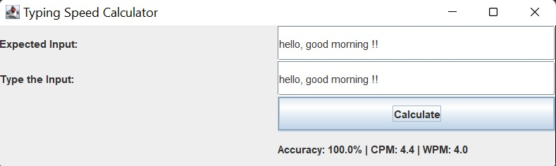

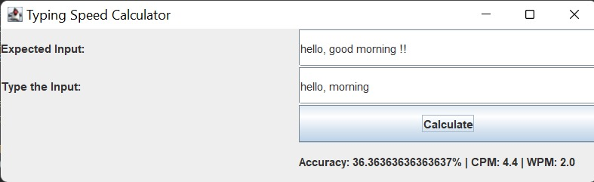

CONCLUSION:

In summary, the typing speed calculator developed using Java emerges as a commendable solution for those seeking to evaluate and refine their typing abilities. The intricately designed application not only offers a seamless user experience but also delivers precise speed measurements, contributing to a comprehensive understanding of one's typing proficiency.

This tool proves to be indispensable for individuals committed to honing their keyboarding skills, providing a tangible means of monitoring progress and setting benchmarks for improvement. Its intuitive interface ensures accessibility, making it suitable for users of varying technical expertise.

As a testament to the versatility and robust capabilities of Java, this typing speed calculator showcases the language's effectiveness in crafting functional and practical software applications. Whether utilized for personal enrichment or as part of professional development, this Java-based calculator stands out as a reliable and valuable resource in the journey towards enhanced typing efficiency.

# BIBLIOGRAPHY:

* “Core Java™, Volume I--Fundamentals (8th Edition) “ , by Cay S. Horstmann, Prentice Hall;8

edition (April 18, 2008).

* “Effective Java (2nd Edition)” , by Addison-Wesley; 2 edition (May 28, 2008).
* “Java The Complete Reference, 8th Edition”, McGraw-Hill Osborne Media; 8 edition (June 22,2011).
* A Programmer's Guide to Java SCJP Certification: A Comprehensive Primer (3rd Edition), Addison-Wesley Professional; 3 edition (December 29,2008).
* “More Java Pitfalls: 50 New Time-Saving Solutions and Workarounds” , by Michael C. Daconta (Author), Kevin T. Smith (Author), Donald Avondolio (Author), W. Clay Richardson (Author), Wiley; 1 edition (February 3,2003).
* “Head First Servlets and JSP: Passing the Sun Certified Web Component Developer Exam “, by Bryan Basham (Author), Kathy Sierra (Author), Bert Bates (Author), O'Reilly Media; Second Edition edition (April 1,2008).
* “Head First Design Patterns”, Elisabeth Freeman (Author), Eric Freeman (Author), Bert Bates (Author), Kathy Sierra (Author), Elisabeth Robson (Author), O'Reilly Media; 1 edition (November 1,2004)
* “EJB 3 in Action”, Debu Panda (Author), RezaRahman (Author), Derek Lane(Author),

Manning Publications; 1 edition (April 16, 2007).

* “JBoss: A Developer's Notebook” , Norman Richards (Author), Sam Griffith (Author),O'Reilly
* Enterprise Java™ Security: Building Secure J2EE™ Applications, Marco Pistoia (Author), NatarajNagaratnam (Author), Larry Koved (Author), Anthony Nadalin (Author), Addison- Wesley Professional; 1 edition (February 27,2004).
* “Java EE 6 Development with NetBeans 7”, Author: David Heffelfinger, Published: June 2011, PACKT Publishing, UK. NetBeans IDE 7.0 Cookbook, Author: RhawiDantas, Published: May 2011, PACKT Publishing,UK
* “Art of Java Web Development: Struts, Tapestry, Commons, Velocity, JUnit, Axis,Cocoon,

InternetBeans, WebWork”, Neal Ford (Author), Manning Publications (November 1, 2003).

* “Struts 2 in Action”, Don Brown (Author), Chad Michael Davis (Author), ScottStanlick

(Author), Manning Publications; 1 edition (May 1, 2008).

* “Hibernate in Action (In Action series)”, Christian Bauer (Author), Gavin King (Author), Manning Publications (August 1, 2004) “Web Services Essentials (O'Reilly XML)”, Ethan Cerami (Author), O'Reilly Media (February 2002).
* “Object-Oriented Software Construction (Book/CD-ROM) (2nd Edition)” ,BertrandMeyer

(Author), Prentice Hall; 2nd edition (March 21, 2000).

* Java Black Book, Steve Holzner (Author), Steven Holzner (Author), Paraglyph Press; Second Edition edition (July 1,2002)

THANK YOU